Attribute – a name and a type (column)
Schema – Table name + a set of attributes
Instance – the values in a table (A set of tuples, every row is unique)
Tuple – one row in an instance
Relation – schema plus an instance

Superkey – A set of attributes is a superkey if no two rows are allowed to have the same values in those columns (no duplicates)
Key – a set of fields is a key it is a superkey, and no proper subset of its fields is a superkey
One key is specified as the primary key, and others are candidate keys
Foreign Key - Attribute whose values are a key in another table

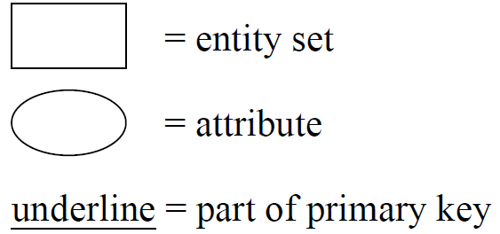
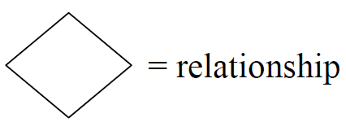

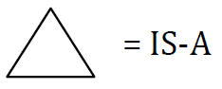

Double line indicates all entities in the set must participate
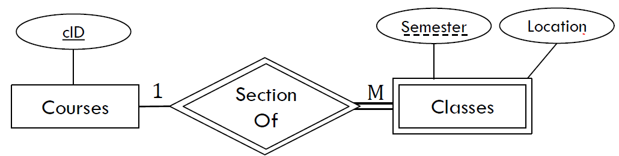
Weak entity + supporting relationship set

ER → Schema:

Many to Many - new schema for the relationship, primary keys of relating entities as foreign keys, key is a combination of the foreign keys
One to Many - merge relationship into the M side entity
One to One – treat as one to many, merge relationship into one of the tables (prefer side with required participation), mark foreign key as unique
Supporting Relationship – is 1 to M, supporting key is combined with partial key
Double Participation – enforced in software, not in schema
Is-A – 1. One schema per entity, pull down just primary key, or
2. No schema for base type, pull down all attributes
Use method 1 if an entity can be two different derived types or the base type has relationships, use method 2 if the base type is ‘abstract’

Schema → SQL

create table <name> (
<column1Name> <type> <properties>,
<column2Name> <type> <properties>,
<table properties>
);

Types – <tiny, small, medium, big>int <unsigned>, float, double, decimal, date, datetime, time, blobs
char(n) – exactly n characters
varchar(n) – up to n characters

Column Properties – not null, default ‘hello’, auto_increment

Table Properties – primary key (col1, col2…)
unique (col1, col2…)
foreign key (col1, col2…) references Table(col1, col2…)
on delete <action> on update <action>
index (col1, col2…)

FK Actions:
RESTRICT(default): disallow the change
CASCADE: also delete/update in child table
SET NULL: nullify key in child table
SET DEFAULT: set to column’s default value

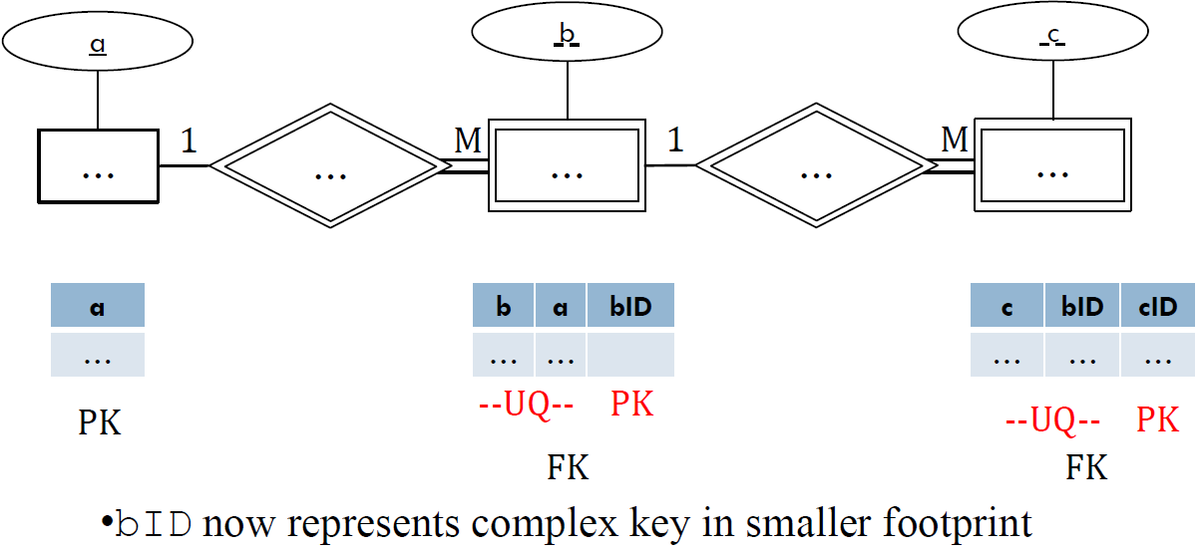

SQL
Select:
SELECT [DISTINCT] <target-list> FROM <relation-list> [WHERE <qualification>]
[ORDER BY <column>] [DESC] [LIMIT <number>];
- target-list and relation-list are comma separated column and table names respectively
- target-list can be *
- qualification is a boolean expression, can use AND, OR, NOT
- WHERE Patrons.CardNum = Phones.CardNum - where on joined table
- IN: SELECT x FROM … WHERE y IN (SELECT …);
- nested query must have same column type(s) as x
- NOT IN: SELECT Addr FROM CorporateLocs WHERE Addr NOT IN (SELECT Addr FROM

Join:
<table> JOIN <table> ON/WHERE <qualification>;
- join returns a temporary table
- qualification same as select
- joins can be chained, (Patrons JOIN CheckedOut) JOIN Inventory

Natural Join – used in place of JOIN, joins on the columns the two tables have in common
Left Join – keeps all rows from left table, uses NULL if right table doesn’t have matching row
Right Join – same as left, but right. BOTH OUTER JOINS REQUIRE ON <condition>
Natural Left/Right Join – only one copy of ‘natural’ columns

Insert:
INSERT INTO <table>[(col1, col2 ...)] VALUES(val1, val2 …);
- inserts into ever column in order if no columns specified
- specify columns if there are null/default/auto_increment columns

Delete:
DELETE FROM <table> WHERE <qualification>
- qualification same as before
- leave out WHERE to delete all rows...

Update:
UPDATE <table> SET col1 = val1, col2 = val2 WHERE < qualification>

Alter:
ALTER TABLE <table> ADD <column>
- <column> is in the same format as when initially creating the table (name, type, properties)

ALTER TABLE <table> MODIFY <column> <new type>
ADD FOREIGN KEY (<column>) REFERENCES <table>(<column>)

Union:
<select statement> UNION <select statement>
- just like union in relational algebra
- use UNION ALL to keep duplicates

Intersect:
<select statement> INTERSECT <select statement>
- not supported by MySQL
- same as natural join if the schemas are the same
Relational Algebra

π − Projection (select) – get certain columns
σ − Selection (where) – get certain rows
× − Cross Product (join) – big combine, column names must be disambiguated
∪ − Set Union - ‘add’, relations must be union compatible
∩ − Set intersect – A ∩ B = A – (A - B)
– - Set difference – relations must be union compatible
⋈ - Natural Join – can be given condition too, shortcut for σ_{condition}(R1 x R2)

ρ – rename a relation, ρ(new-name, expression)
- can also rename columns ρ(new-name_{newCol/oldCol}, expression)

Output of RA query must be a relation (no duplicates)

Division (/):
